**RESUME**

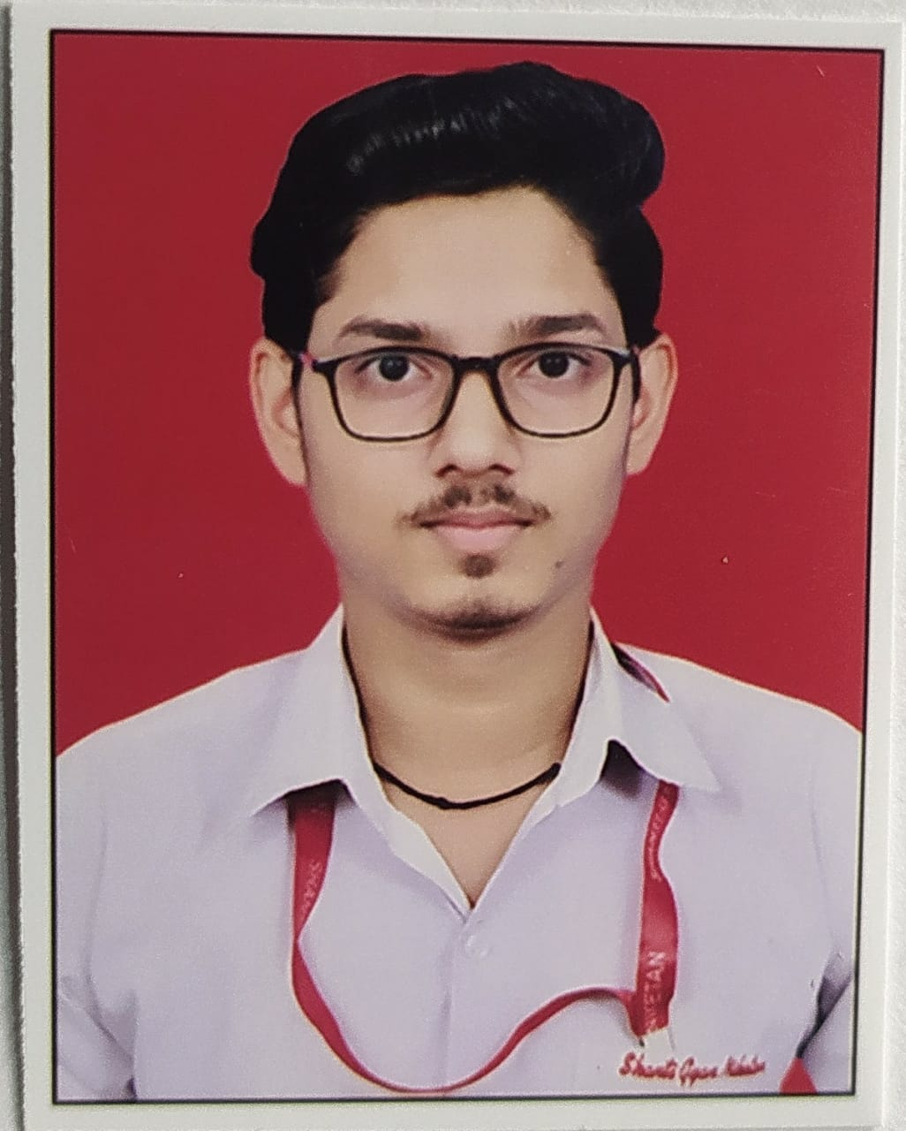PHOTO

**Complete Name- Deepanshu**

Address:- B-26 V.P.O Chhawla Village ,New Delhi-110071

Email ID:- deepanshu.kr1225@gmail.com

Contact No. :- 7303939578

Linkedin Profile link - https://www.linkedin.com/in/deepanshu-54388a22b

**CAREER OBJECTIVE:**

* To be the part of an enthusiastic work environment, where I can use my technical skills to accomplish organizational goals.

ACADEMIC BACKGROUND:

Pursuing B.Tech in COMPUTER SCIENCE ENGINEERING & TECHNOLOGY from dronacharya college of Enginnering, Gurgoan, Approved by AICTE.

|  |  |  |  |
| --- | --- | --- | --- |
| Institute/University | Degree/Examination | Percentage | Year |
| Dronacharya College Of Engg. | B.Tech | ------ | 2021-25 |
| Shanti Gyan Niketan School, New Delhi | 12th | 80.8% | 2021 |
| Shanti Gyan Niketan School ,New elhi | 10th | 70% | 2019 |

**TECHNICAL SKILLS:**

* Language   :  Basic concepts of C, Python language,Html,Css.

# CERTIFICATIONS AND MEMBERSHIPS:

* Certification of poster making organised on the eve of Reublic Day 2022.

# WORKSHOPS AND TECHNICAL EVENTS:

* Participated in poster making compition held at Dronacharya college of Engineering on 25th January 2022.
* Attended two days Web Development Workshop at Dronacharya College of Enginnering in December 2021.
* Atttended Drone workshop at Dronacharya college of Engineering in Decmber 2021.

**STRENGTHS:**

* The ability to Work in a team.
* Hard-working with lots of patience.

**EXTRACURRICULAR ACTIVITIES:**

* volleyball Player.
* Playing Outdoor and Indoor games like Carrom ,Ludo,etc